**Steps for Role Assignments and Azure Monitor Configuration:**  
  
**Assign Reader Access to the Azure Resource:**  
==>Navigate to the Azure Virtual Machine (ARVAZAPP19) in the Azure Portal.  
==> Go to Access control (IAM) and click + Add → Add role assignment.  
  
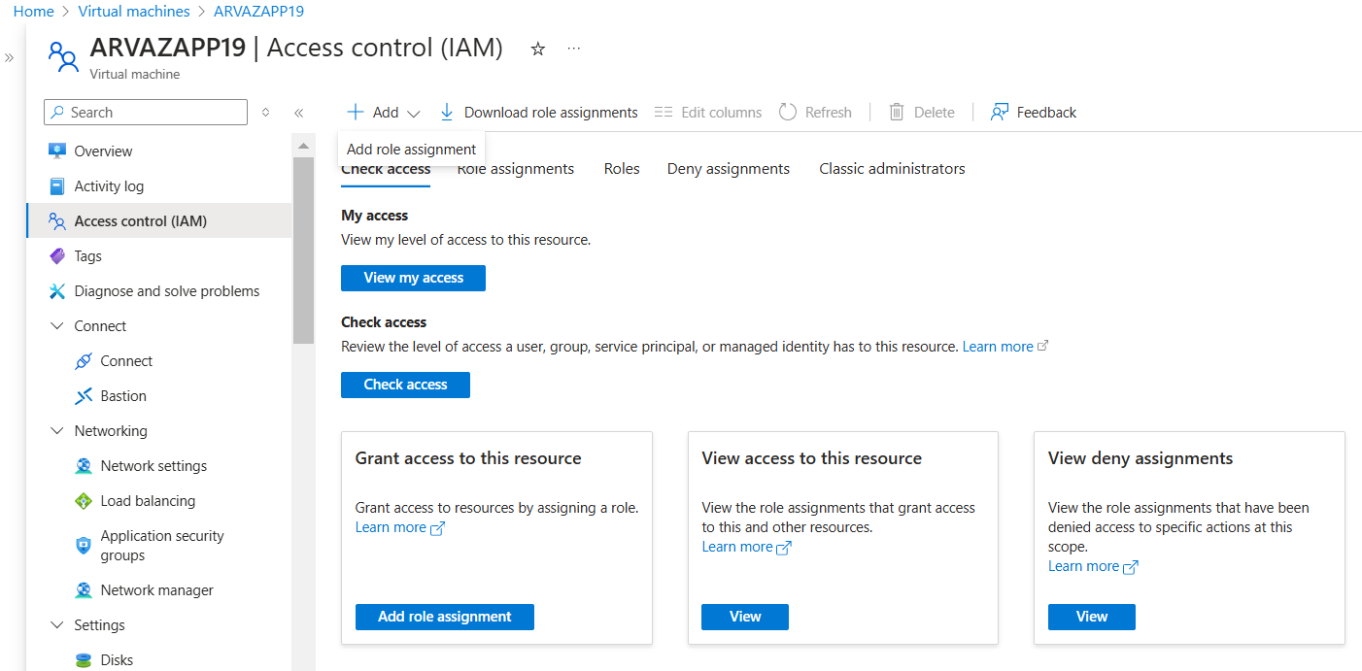  
  
  
  
==>In the Add role assignment pane:  
==> Select the Reader role (allows viewing resources) and click Next.  
  
== Under Members, choose the security group (e.g., ACLC-AZURE-ARVAZAPP19-INSIGHTS) and click Review + Assign.

==>Verify that the Reader role is now assigned to the specified security group.  
  
**Check Azure Monitor Configuration:**  
  
==>Go to Azure Monitor in the Azure Portal.  
==>Click on Virtual Machines. Search for the VM (ARVAZAPP19) under Monitored or Not Monitored.  
  
  
==>If the VM is not enabled for monitoring: Click Enable.

==>Choose either the default Data Collection Rule (DCR) or create a new DCR based on your requirements.  
  
  
**Assign Reader Role to the Security Group for the DCR:**  
  
==> Navigate to the DCR resource. Go to Access control (IAM) and click + Add → Add role assignment.

==>Assign the Reader role to the same security group (ACLC-AZURE-ARVAZAPP19-INSIGHTS).

Verify Role Assignments:  
  
  
==>Confirm that the security group now has two Reader roles assigned:

One for the VM (ARVAZAPP19). Another for the DCR (if applicable).  
  
==> Members of the security group will now have the necessary permissions to view insights for the Azure resource.  
  
